September 14th, 2026
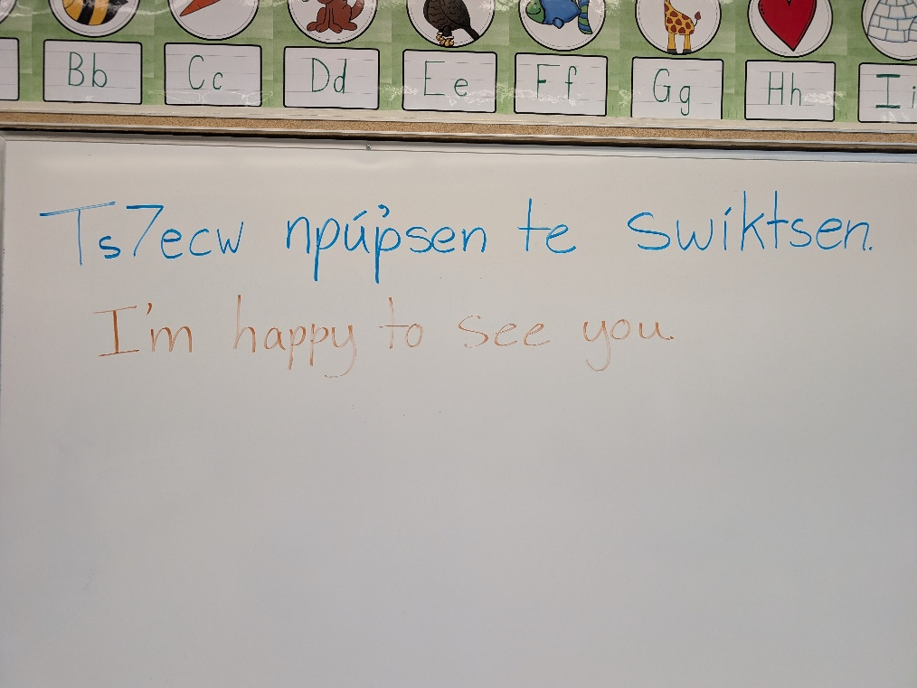
The first week is a wrap! It was heartwarming to see big smiles on students' faces as they reunited with their friends. This week was all about reconnecting, building a sense of belonging and easing into the schoolyear. Students were mixed into grade groups with a temporary teacher for the week. They met new friends, readjusted to the excitement of school and became familiar with a new adult. All students are sorted into their permanent classrooms now and will start building classroom community and routines on Monday.
Lunch Programs:
Hot lunch will start in October. Check your emails in the coming weeks for more details.
Breakfast Club will be open to all students every morning. A light breakfast will be served to help those hungry kids who either didn't eat breakfast or would like a bit more food before the school day starts. Breakfast club room is accessible from the playground and it open at 8:30.
Supported Lunch Program: Contact the school or the Principal at jackie.plant@sd27.bc.ca if you could use the help providing your children with nutritious lunches.
School Photos: Our photographer will be coming Tuesday October 6th for Primary classes (Including the 3/4 classes) and October 7th for Intermediate classes.
PAC Meeting: Our first Parent Advisory Council Meeting takes place this Thursday, September 17th at 5:30. We will meet in the library. All parents and caregivers are welcomed and encouraged to come. You will receive a Principal's report of happenings at the school and help plan ways to get involved in the school.
Terry Fox Run: The annual Terry Fox run will take place Friday September 25th. Donations are now being accepted. All money will go towards Cancer Research. Students who donate will be recognized by adding a paper shoe to the school walls. Donations can be made in cash or through this online link: 100 Mile House Elementary - 100 Mile House, BC | Terry Fox School Run
Orange Shirt Day: Our incredible Indigenous Support Worker, Penny, has arranged for Phyllis Webstad and other inspirational speakers to come and deliver a special event. Details to follow. Event will be on Monday, September 28th. Students are encouraged to wear an orange shirt.
That will bring us to October!
Take Care and thank you for all your support during our school start up.
-Jackie Plant (Ms. Hunt)

